**JMeter API Testing**

Site to be testing:

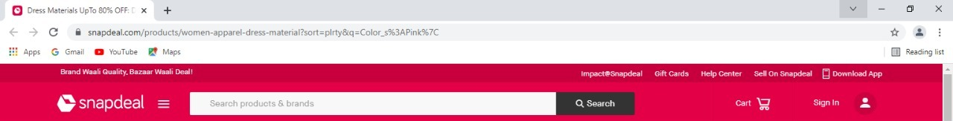

API of Site:

<https://www.snapdeal.com/products/women-apparel-dress-material>?sort=plrty& q=Color_s%3APink%7C

Steps

1. Create test plan
2. Create Thread Group

Name:API Testing

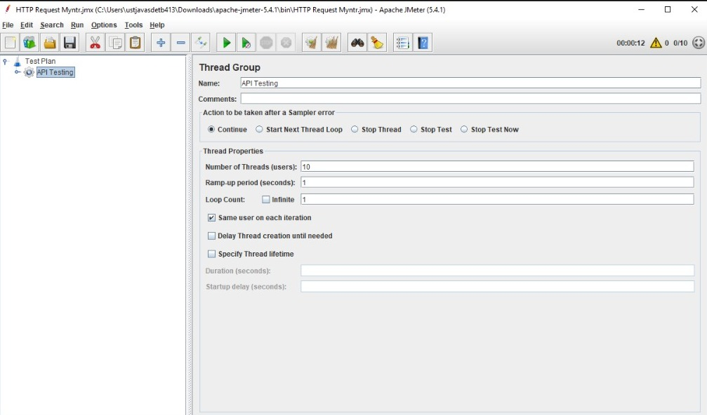

1. Create HTTP Request

Server name : [www.snapdeal.com](http://www.snapdeal.com)

Path : /products/women-apparel-dress-material

Parameters : sort=plrty q=Color_s%3APink%7C

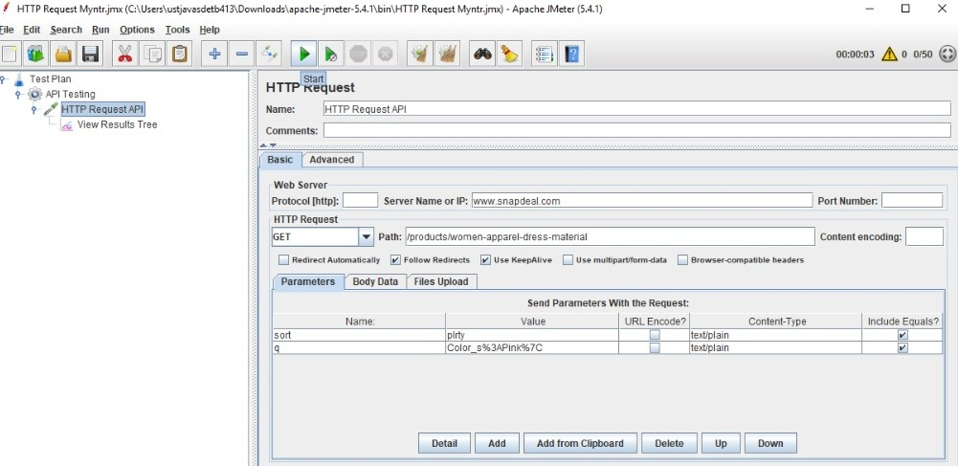

1. Add Listener – View Results Tree
2. Save and Run Http Request API

Result :

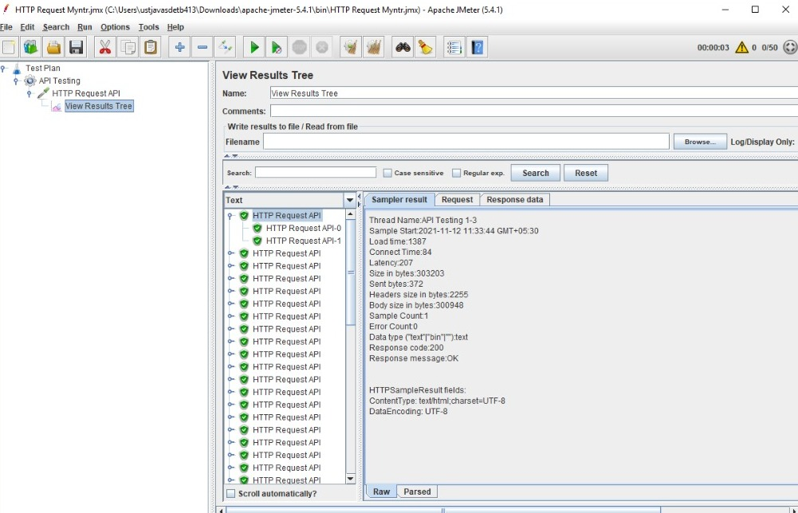

1. Add Assertion

To check the Respose code

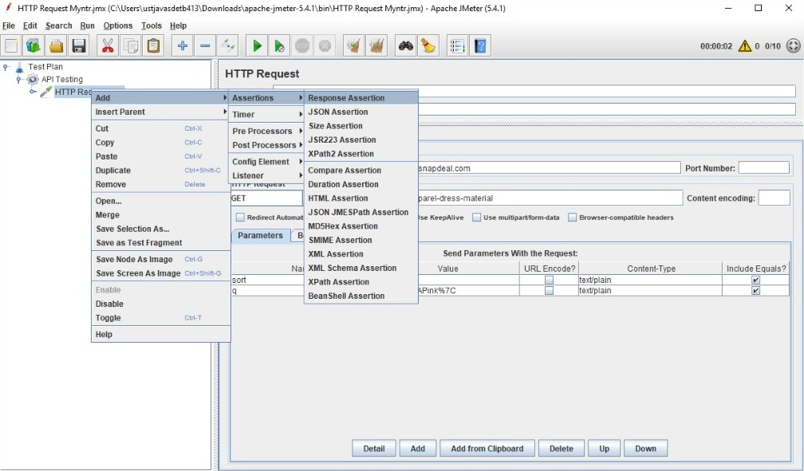

* set Field to Test as Response Code
* set Patterns Matching Rules as Equals
* set Patterns to Test as A value of response code
* set Custom Failure Message [message to print if it is error]

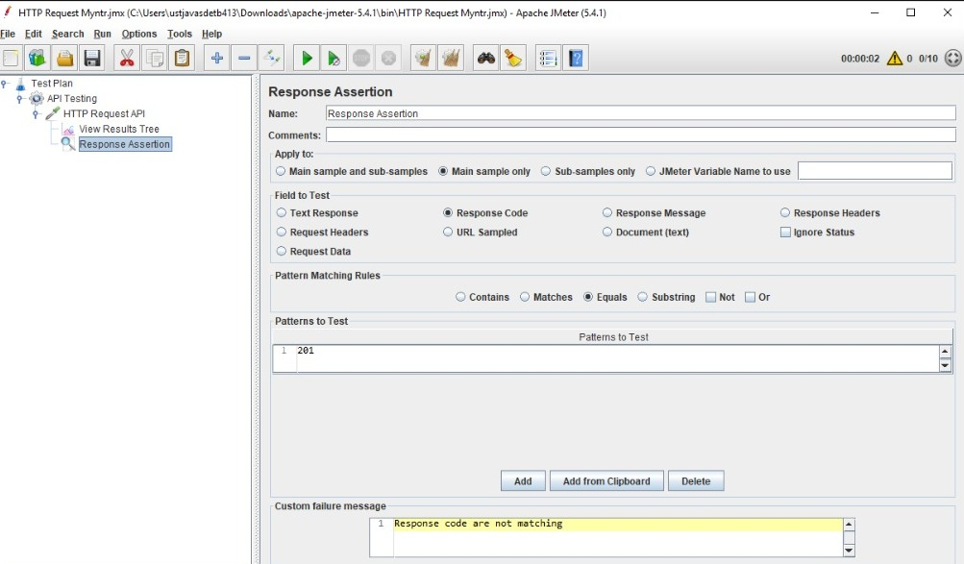

* In this assertion Response code pattern to test is different so it shows some errors

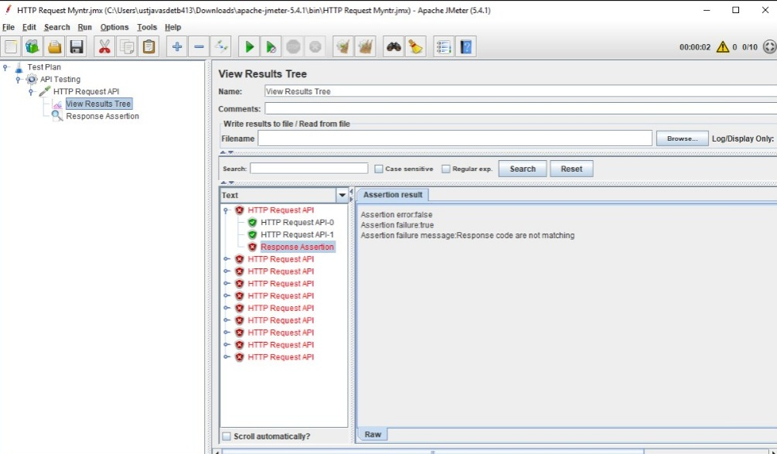

* If Response code is Same

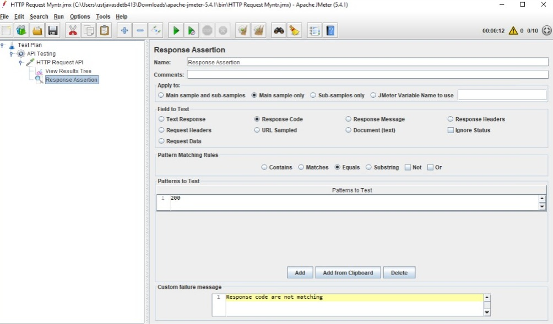

Result:

